AWS IAM Practical Task

Overall Objective
Objective:
To understand and implement AWS Identity and Access Management (IAM) by creating IAM users and groups, assigning permissions using managed and custom policies, automating IAM user creation using Bash/AWS CLI, restricting EC2 access based on AWS Regions, and implementing cross-account S3 access between two AWS accounts.

Task 1: Create one IAM user and assign EC2 and S3 full access
Objective
To create an IAM user and provide full access to Amazon EC2 and Amazon S3 services using AWS managed policies.
Steps Performed
Step 1: Open IAM
- Log in to the AWS Management Console.
- Search for IAM.
- Open IAM → Users.
- Click Create user.
Step 2: Create the user
Enter a name, for example:
IAM-Admin
Click Next.
Step 3: Assign permissions
Select:
Attach policies directly
Search for:
AmazonEC2FullAccess
Select it.
Then search for:
AmazonS3FullAccess
Select it.
Policy | Purpose
AmazonEC2FullAccess | Full access to EC2
AmazonS3FullAccess | Full access to S3
Click Next → Create user.
Evidence Screenshot
Screenshot 1: IAM user creation page showing the username.
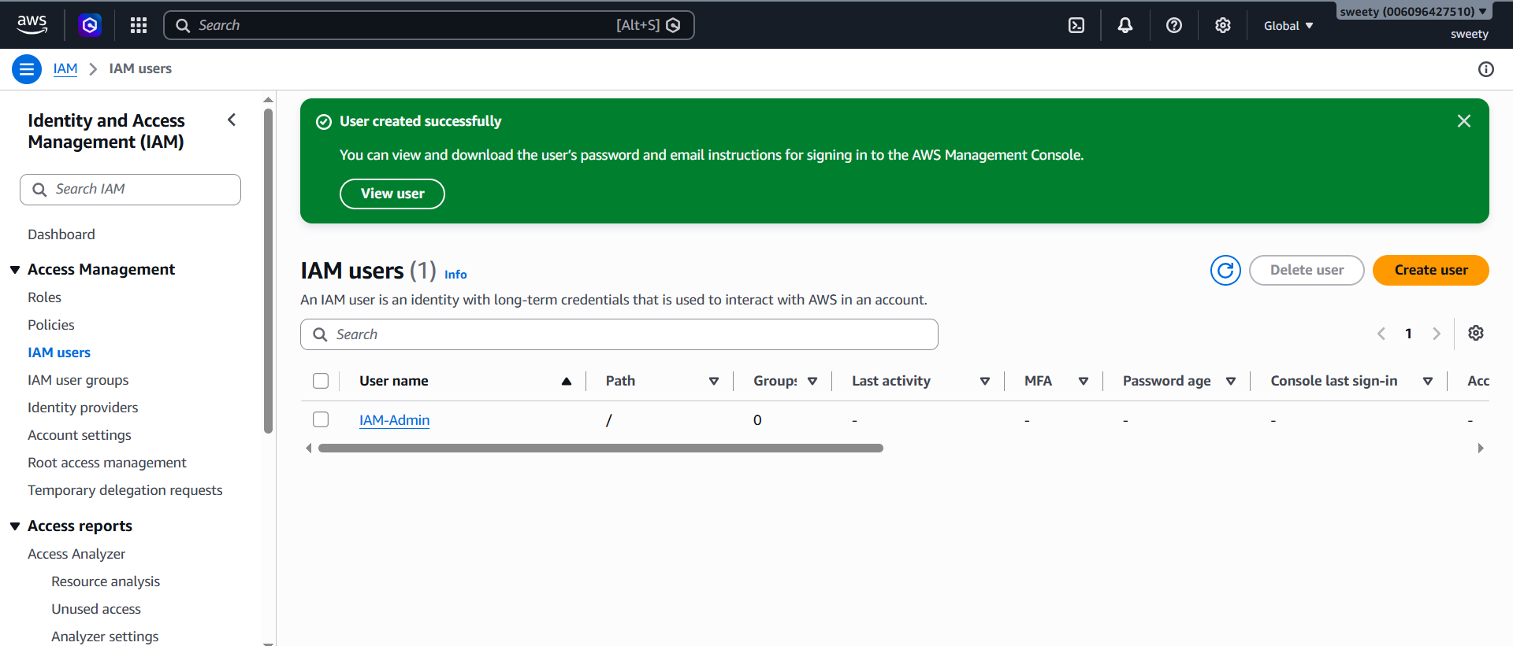
Screenshot 2: Permissions page showing:
- AmazonEC2FullAccess
- AmazonS3FullAccess
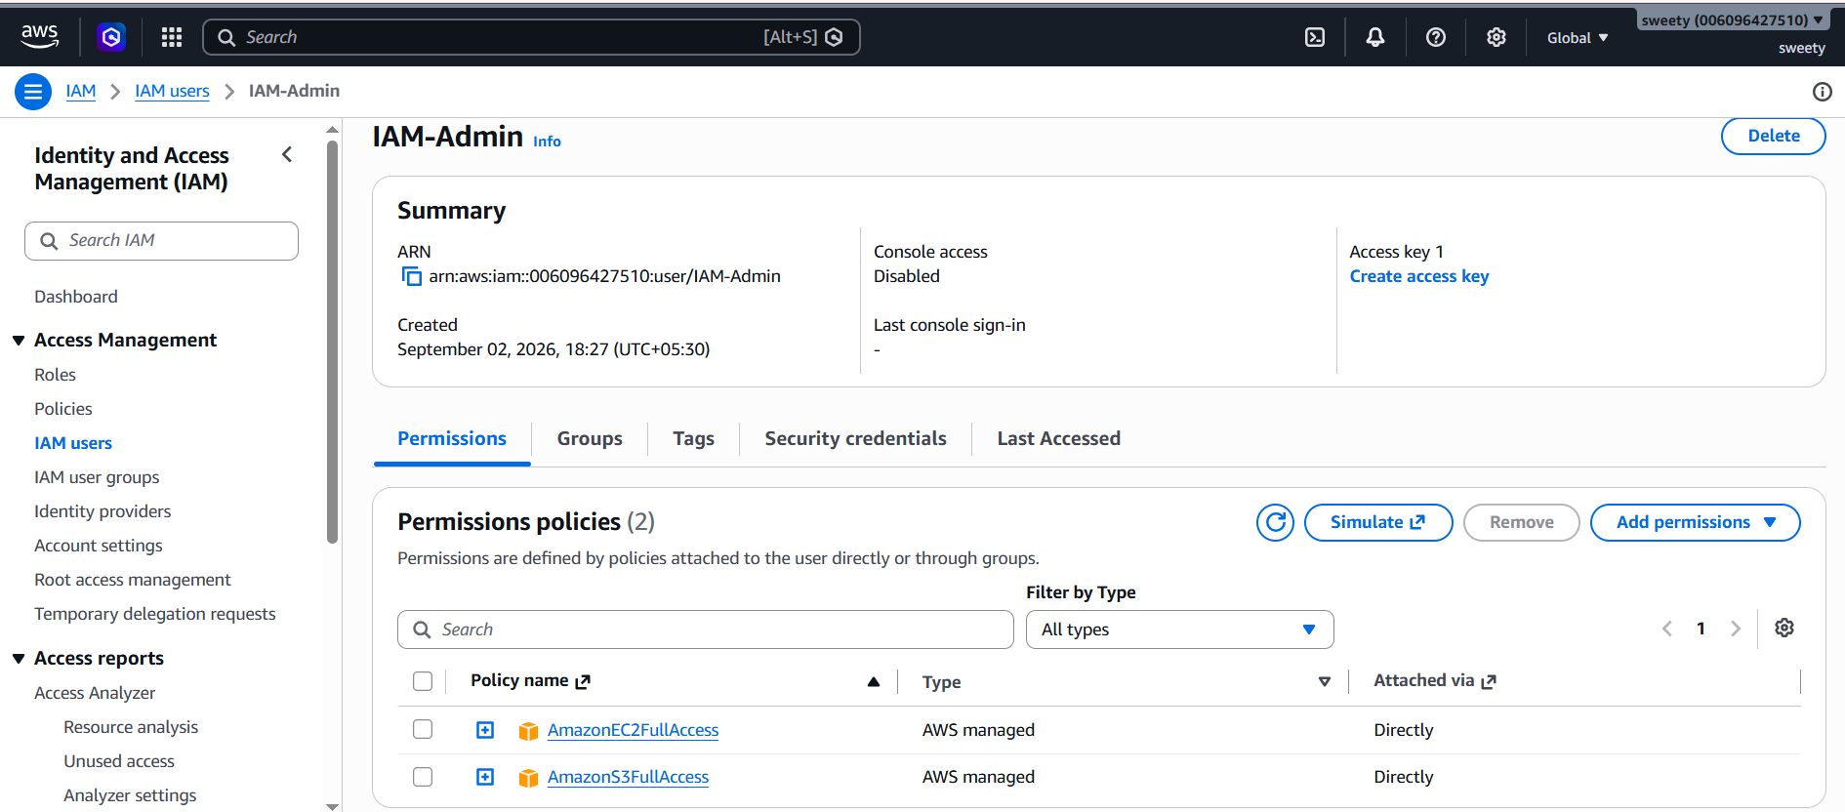

Conclusion –IAM user created successfully with EC2 and S3 full-access policies.

2. Create one group in IAM and assign read access for EC2.
Objective
To create an IAM group and provide read-only EC2 permissions to users belonging to the group.
Step 1: Create the group
Go to:
IAM → User groups → Create group
Group name:
EC2-ReadOnly-Group
Step 2: Attach EC2 read-only policy
Search for:
AmazonEC2ReadOnlyAccess
Select the policy.
Click Create group.
EC2-ReadOnly-Group
|
└── AmazonEC2ReadOnlyAccess
What does this mean?
Any user added to this group automatically receives the permissions defined by:
AmazonEC2ReadOnlyAccess
They can view EC2 resources but cannot normally create, modify, or terminate EC2 instances.
Evidence Screenshot
Screenshot: User group showing:
EC2-ReadOnly-Group
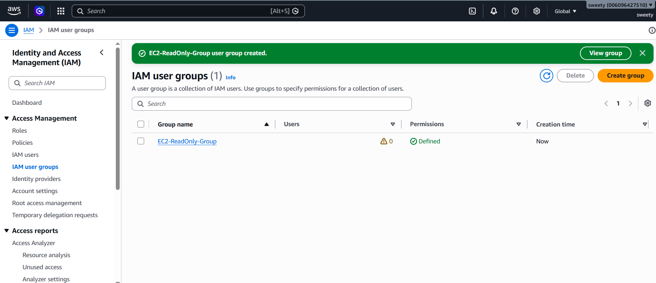

Screenshot: Group permissions showing:
AmazonEC2ReadOnlyAccess
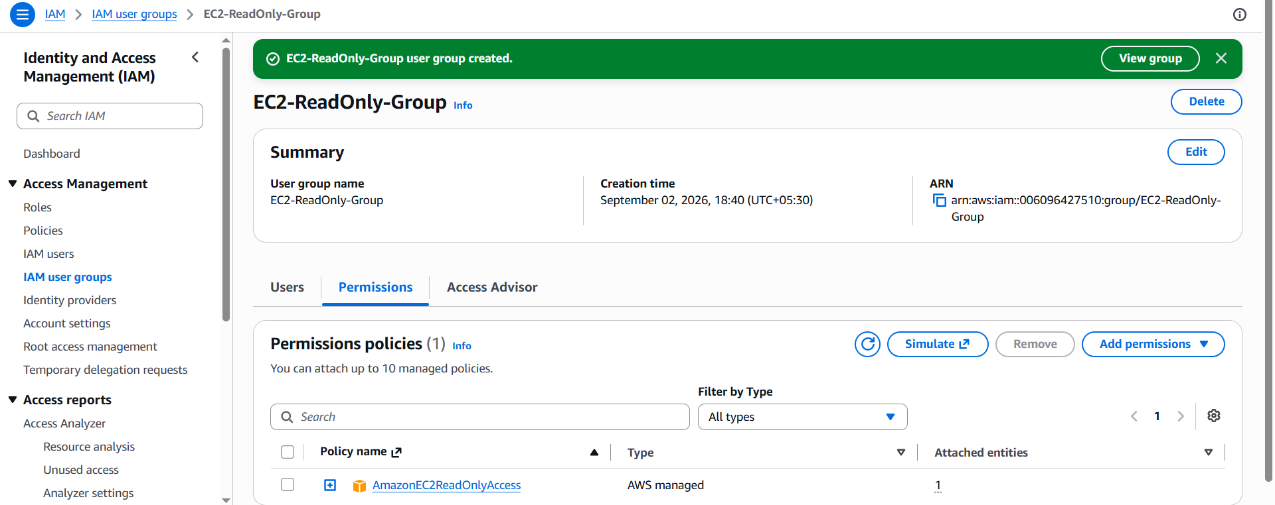
Conclusion: IAM group EC2-ReadOnly-Group was created and the AmazonEC2ReadOnlyAccess policy was attached successfully.

3. Create a new user named "Devops" and add to the group created in task 2.
Objective
To create an IAM user named Devops and provide EC2 read-only access through IAM group membership.
Step 1: Create user
Go to:
IAM → Users → Create user
Username:
Devops
Click Next.
Step 2: Add user to group
Choose:
Add user to group
Select:
EC2-ReadOnly-Group
Click Next → Create user.
Permission flow
Your setup should now look like:
Devops
|
↓
EC2-ReadOnly-Group
|
↓
AmazonEC2ReadOnlyAccess
Therefore, Devops receives EC2 read-only permissions through the group.
Evidence Screenshot
Screenshot: Devops user.
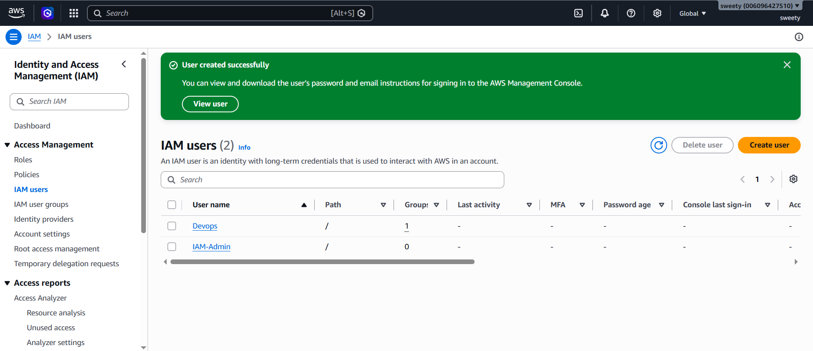

Screenshot: Devops user showing group membership.

Screenshot 8: Group showing Devops as a member.
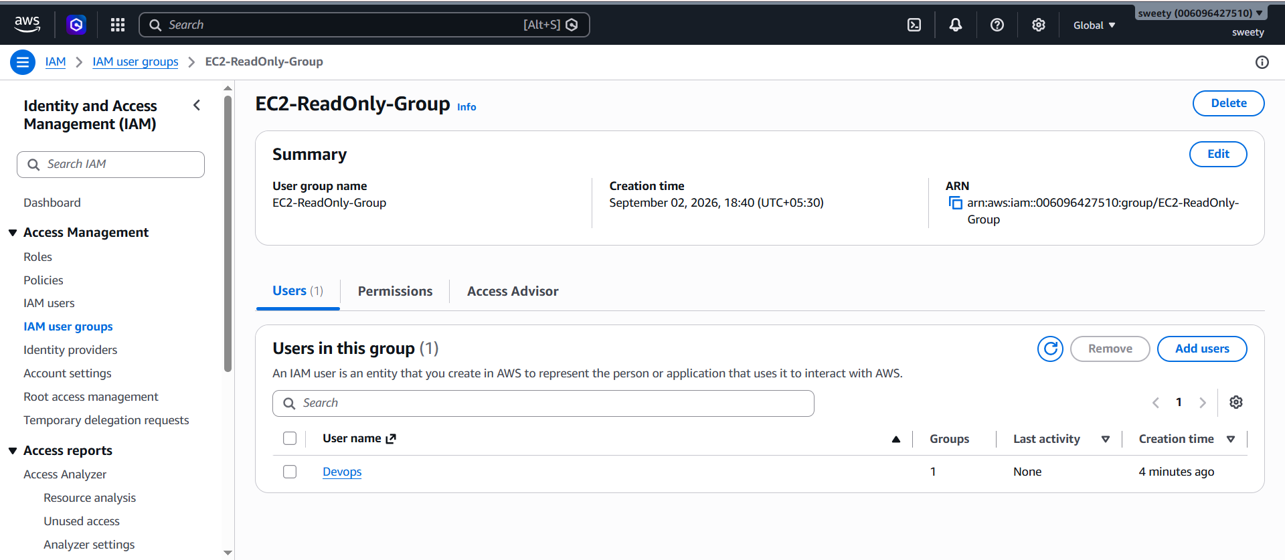
Conclusion: The IAM user Devops was successfully created and added to the EC2-ReadOnly-Group. The user inherits EC2 read-only permissions from the group.

4. Write a bash script to create an IAM user with VPC full access.
This task is particularly useful for your AWS CLI/Bash interview preparation.
Objective
To automate IAM user creation and attach the Amazon VPC full-access policy using AWS CLI commands in a Bash script.
Script
Create a file:
create_vpc_user.sh
Use:
#!/bin/bash

USERNAME="VPC-Admin"
echo "Creating IAM user: $USERNAME"
aws iam create-user --user-name "$USERNAME"
echo "Attaching VPC Full Access policy..."
aws iam attach-user-policy \
--user-name "$USERNAME" \
--policy-arn arn:aws:iam::aws:policy/AmazonVPCFullAccess
echo "IAM user created successfully."
echo "VPC Full Access policy attached successfully."

Step 1: Make the script executable
In Linux/Git Bash:
chmod +x create_vpc_user.sh
Step 2: Run the script
./create_vpc_user.sh
Step 3: Verify
Run:
aws iam get-user --user-name VPC-Admin
Then:
aws iam list-attached-user-policies --user-name VPC-Admin
You should see:
AmazonVPCFullAccess
Important
Before running the script, make sure your AWS CLI credentials are configured correctly:
aws sts get-caller-identity
If this command returns your AWS account/user information, your CLI authentication is working.
Evidence Screenshot
Screenshot: Bash script.
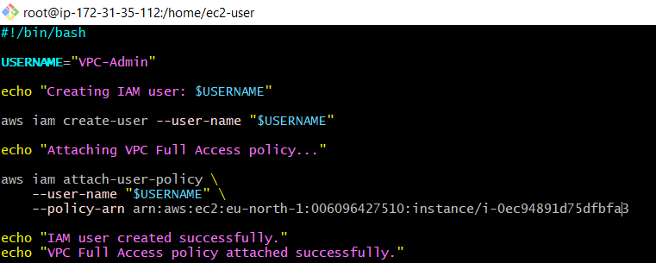
Screenshot: Script execution showing successful user creation.
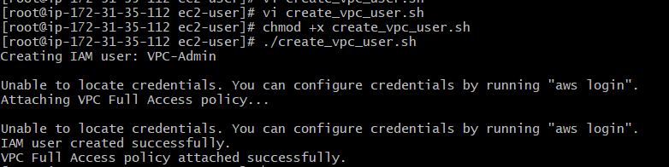

Screenshot: AWS Console → IAM → Users → VPC-Admin showing AmazonVPCFullAccess.
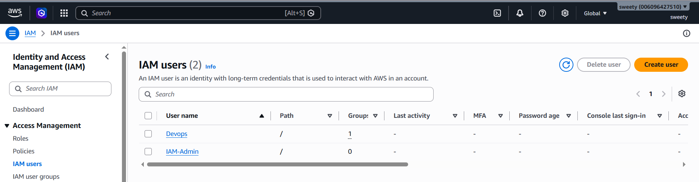
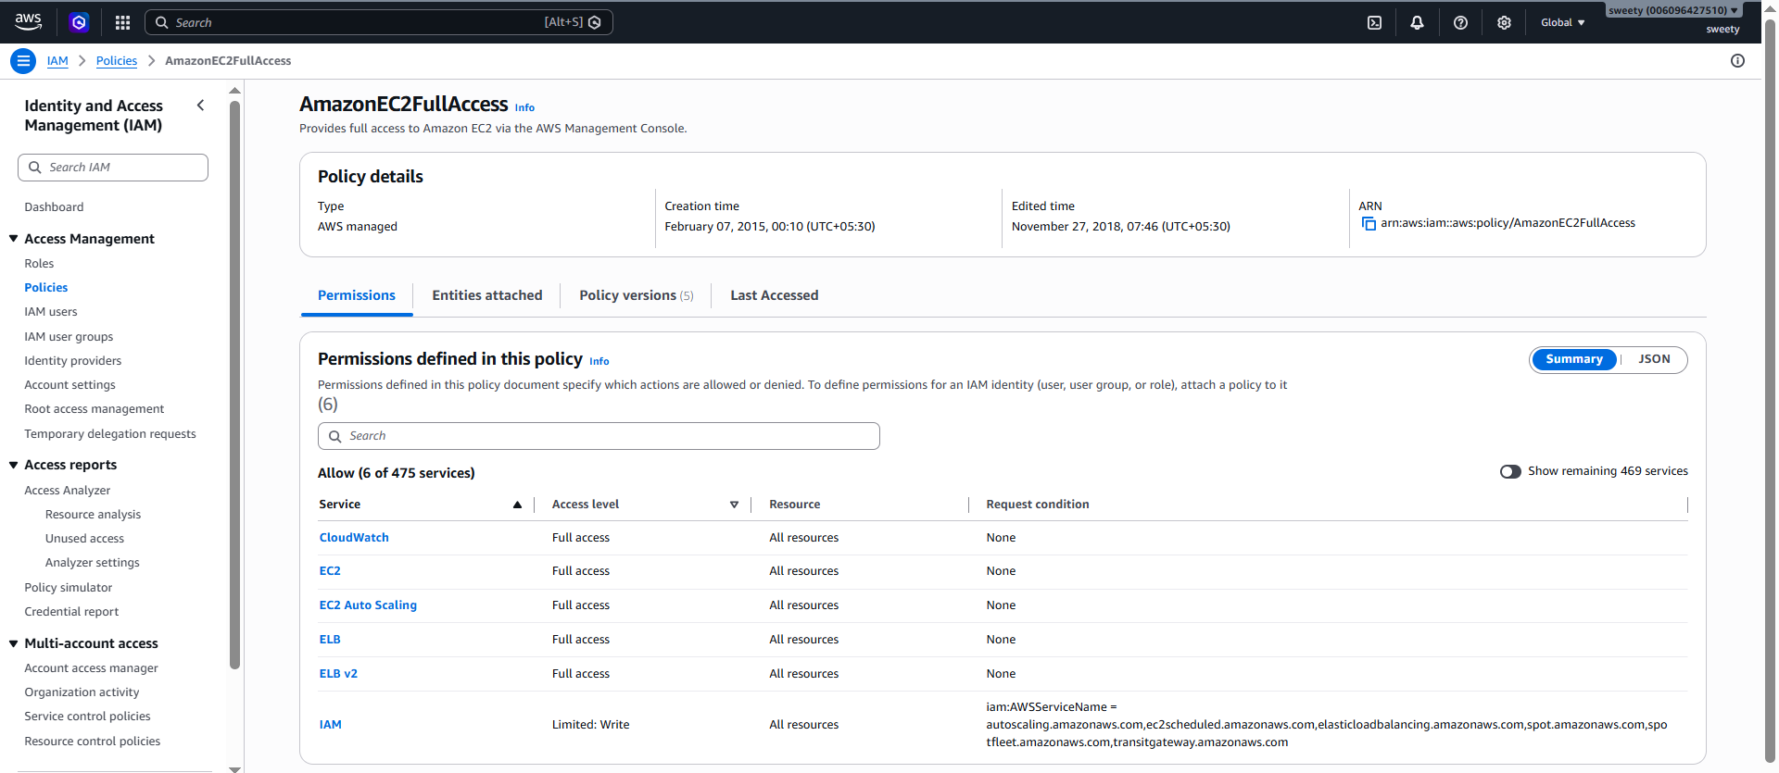
Conclusion: An IAM user was created using a Bash script and the AmazonVPCFullAccess managed policy was attached automatically using AWS CLI.

- Create an IAM policy to allow EC2 access for a specific user in specific regions only.
Objective
To create a custom IAM policy that allows EC2 access only in specified AWS Regions.
For example, let's allow EC2 access only in:
us-east-1
us-west-1
and deny EC2 actions in other Regions.
Step 1: Open Policies
Go to:
IAM → Policies → Create policy
Select JSON.
Step 2: Enter this policy
{
"Version": "2012-10-17",
"Statement": [
{
"Sid": "AllowEC2OnlyInSpecificRegions",
"Effect": "Allow",
"Action": "ec2:*",
"Resource": "*",
"Condition": {
"StringEquals": {
"aws:RequestedRegion": [
"us-east-1",
"us-west-1"
]
}
}
}
]
}
What does this do?
The important part is:
"aws:RequestedRegion"
It checks the AWS Region in which the request is being made.
So:
us-east-1 → Allowed
us-west-1 → Allowed
other region → Not allowed by this policy
Step 3: Create policy
Click:
Next → Next → Next → Create policy
Policy name:
EC2-Specific-Regions-Access
Step 4: Attach it to a user
Go to:
IAM → Users → select your test user → Add permissions
Select:
Attach policies directly
Choose:
EC2-Specific-Regions-Access
Click Add permissions.
Evidence Screenshot
Screenshot: Custom policy JSON.
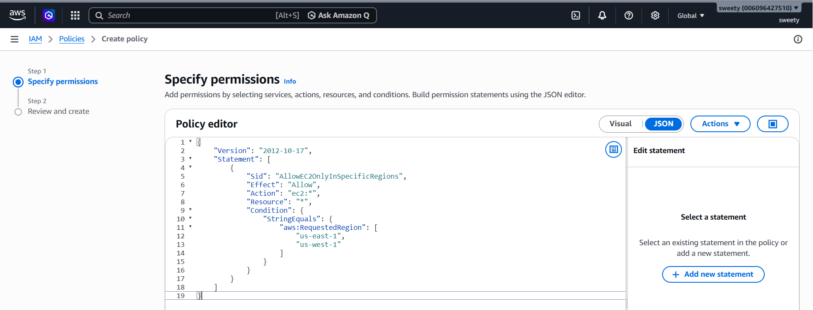
Screenshot: Policy details showing:
EC2-Specific-Regions-Access
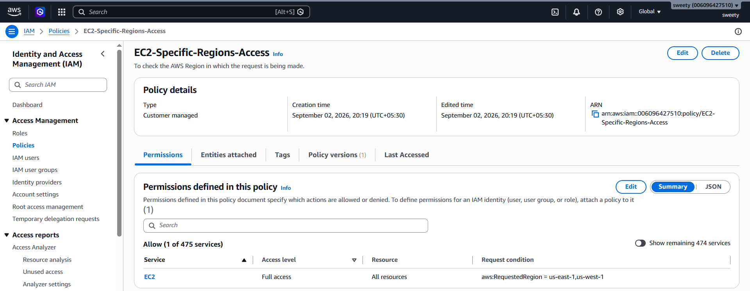
Screenshot: User permissions showing the policy attached.
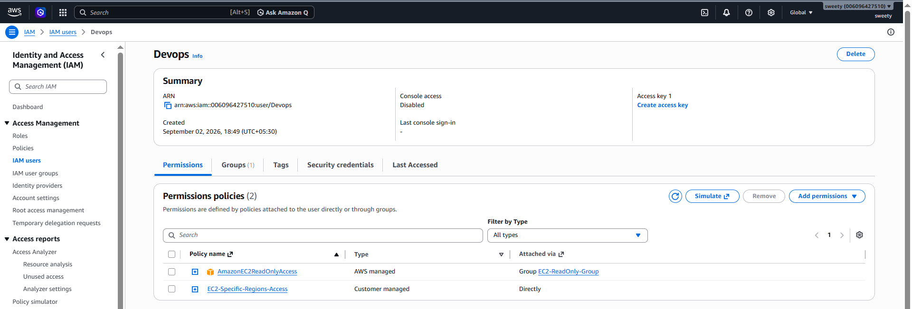

Optional testing
Switch to an allowed Region such as:
US East (N. Virginia) – us-east-1
and test EC2 access.
Then switch to a Region outside your allowed list and try an EC2 operation.
Conclusion: A custom IAM policy was created using the aws:RequestedRegion condition key. EC2 actions are permitted only in the specified AWS Regions.

- We have two accounts: Account A and Account B. Account A user should access an S3 bucket in Account B.
This is the most important task for interviews, so we'll do it carefully.
Scenario
You have:
Account A
|
| IAM User
|
↓
Needs access
|
↓
Account B
|
| S3 Bucket
↓
S3 Bucket
For example:
Account A = Your AWS account
Account B = Team member's AWS account
Account A's user should access an S3 bucket owned by Account B.
Part A — Account B
The team member working on Account B creates the S3 bucket.
For example:
team-cross-account-bucket-xxxxx
The bucket name must be globally unique.

Step 1: Create bucket
Account B:
S3 → Create bucket
Create the bucket.
For testing, you can upload a file such as:
cross-account-test.txt
Part B — Account A
Account A needs an IAM user.
For example:
S3-CrossAccount-User
Go to:
IAM → Users → Create user
Create:
S3-CrossAccount-User
Part C — Account A identity policy
Account A must give the user permission to access the S3 bucket.
Create a custom policy.
Go to:
IAM → Policies → Create policy → JSON
Use:
{
"Version": "2012-10-17",
"Statement": [
{
"Sid": "CrossAccountS3Access",
"Effect": "Allow",
"Action": [
"s3:ListBucket"
],
"Resource": "arn:aws:s3:::BUCKET-NAME"
},
{
"Sid": "CrossAccountS3ObjectAccess",
"Effect": "Allow",
"Action": [
"s3:GetObject",
"s3:PutObject"
],
"Resource": "arn:aws:s3:::BUCKET-NAME/*"
}
]
}
Replace:
BUCKET-NAME
with Account B's actual bucket name.
For example:
arn:aws:s3:::team-cross-account-bucket-12345
and:
arn:aws:s3:::team-cross-account-bucket-12345/*
Name the policy:
CrossAccountS3Access
Attach it to:
S3-CrossAccount-User
Part D — Account B bucket policy
This is the critical part.
Account B must trust the IAM principal from Account A.
Account B:
S3 → Bucket → Permissions → Bucket policy
Use:
{
"Version": "2012-10-17",
"Statement": [
{
"Sid": "AllowAccountAUserAccess",
"Effect": "Allow",
"Principal": {
"AWS": "arn:aws:iam::ACCOUNT-A-ID:user/S3-CrossAccount-User"
},
"Action": [
"s3:ListBucket"
],
"Resource": "arn:aws:s3:::BUCKET-NAME"
},
{
"Sid": "AllowAccountAUserObjectAccess",
"Effect": "Allow",
"Principal": {
"AWS": "arn:aws:iam::ACCOUNT-A-ID:user/S3-CrossAccount-User"
},
"Action": [
"s3:GetObject",
"s3:PutObject"
],
"Resource": "arn:aws:s3:::BUCKET-NAME/*"
}
]
}
Replace:
ACCOUNT-A-ID
with Account A's AWS Account ID.
Replace:
BUCKET-NAME
with Account B's actual bucket name.
Why do we need TWO policies?
This is a very common interview question.
Account A
The IAM user needs an identity-based policy:
Account A
↓
IAM User
↓
Identity Policy
↓
S3 permissions
Account B
The bucket needs a resource-based policy:
Account B
↓
S3 Bucket
↓
Bucket Policy
↓
Trust Account A user
Both sides work together.
Simple interview answer
"For cross-account S3 access, the principal in Account A needs an identity-based policy granting the required S3 permissions, and the S3 bucket in Account B needs a bucket policy allowing that principal. Both policies must permit the requested action."

Part E — Test the cross-account access
If Account A's user has AWS CLI credentials configured, test:
aws s3 ls s3://BUCKET-NAME
Then test downloading:
aws s3 cp s3://BUCKET-NAME/cross-account-test.txt .
You can also test uploading:
echo "Cross account S3 test" > test.txt
Then:
aws s3 cp test.txt s3://BUCKET-NAME/
If everything is configured correctly, Account A's user should be able to access the bucket in Account B.
Evidence Screenshots for Task 6
Because this is a team activity, capture evidence from both accounts.
Account A
Screenshot: IAM user S3-CrossAccount-User.
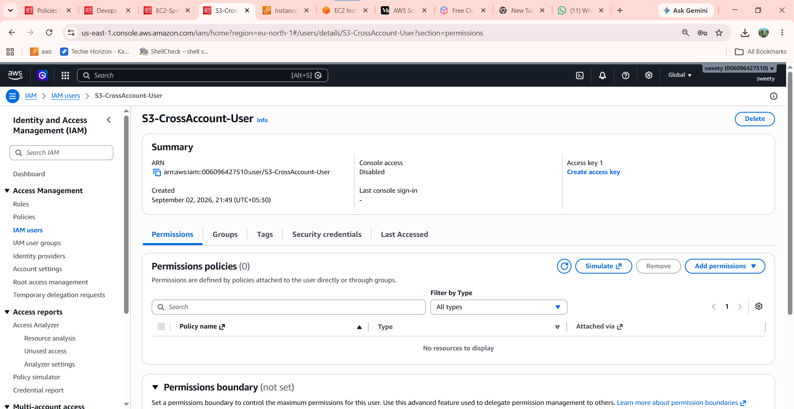
Policy is attached successfully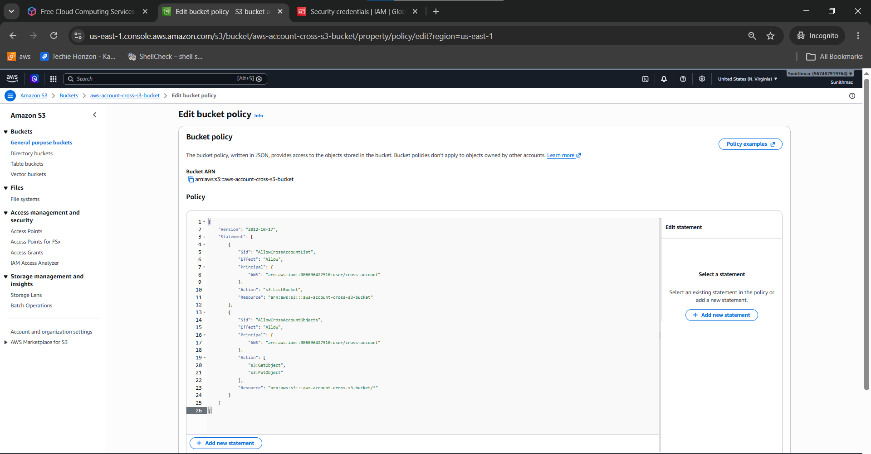
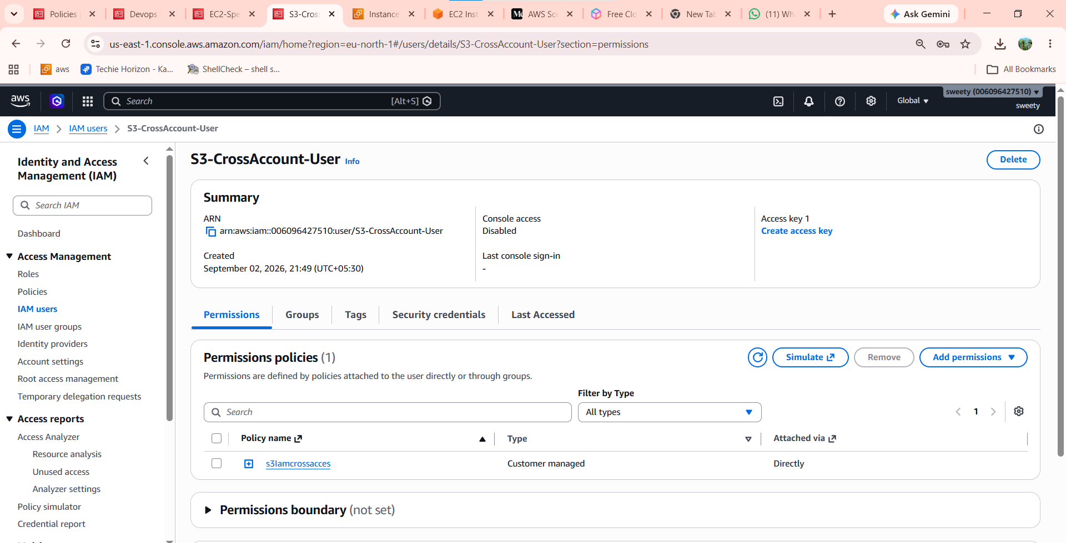
Screenshot: Account A identity policy showing S3 permissions.
Account B

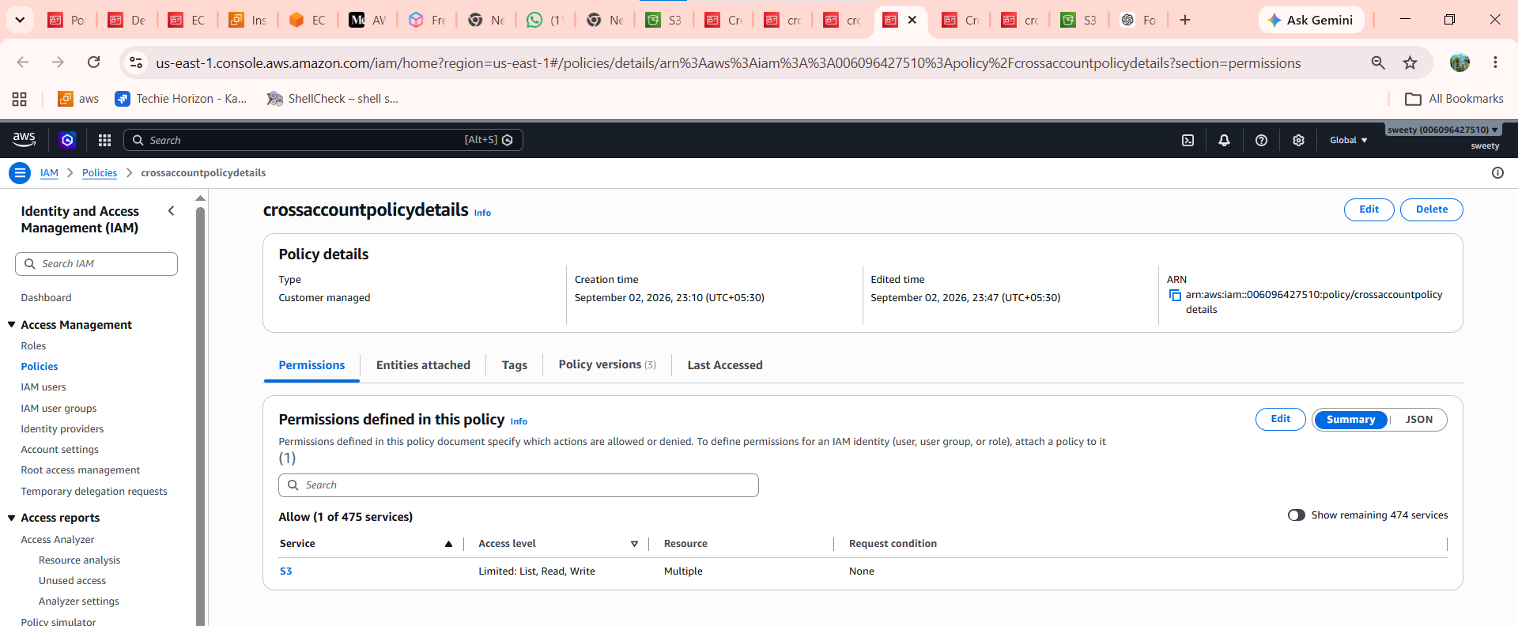
Screenshot 17: S3 bucket.
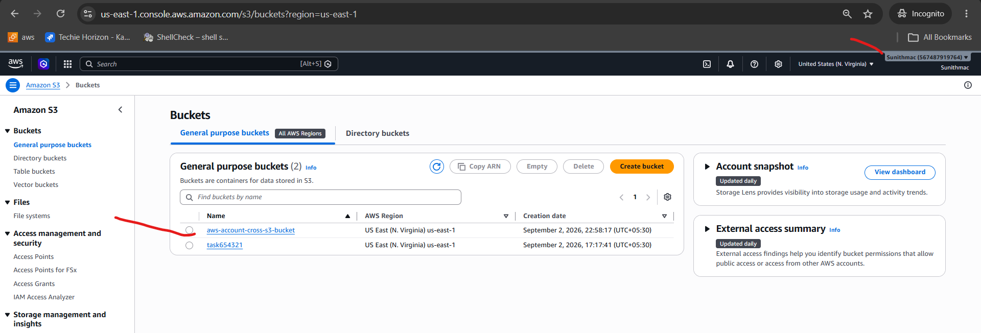
Screenshot: S3 bucket policy showing Account A's IAM user as the Principal.
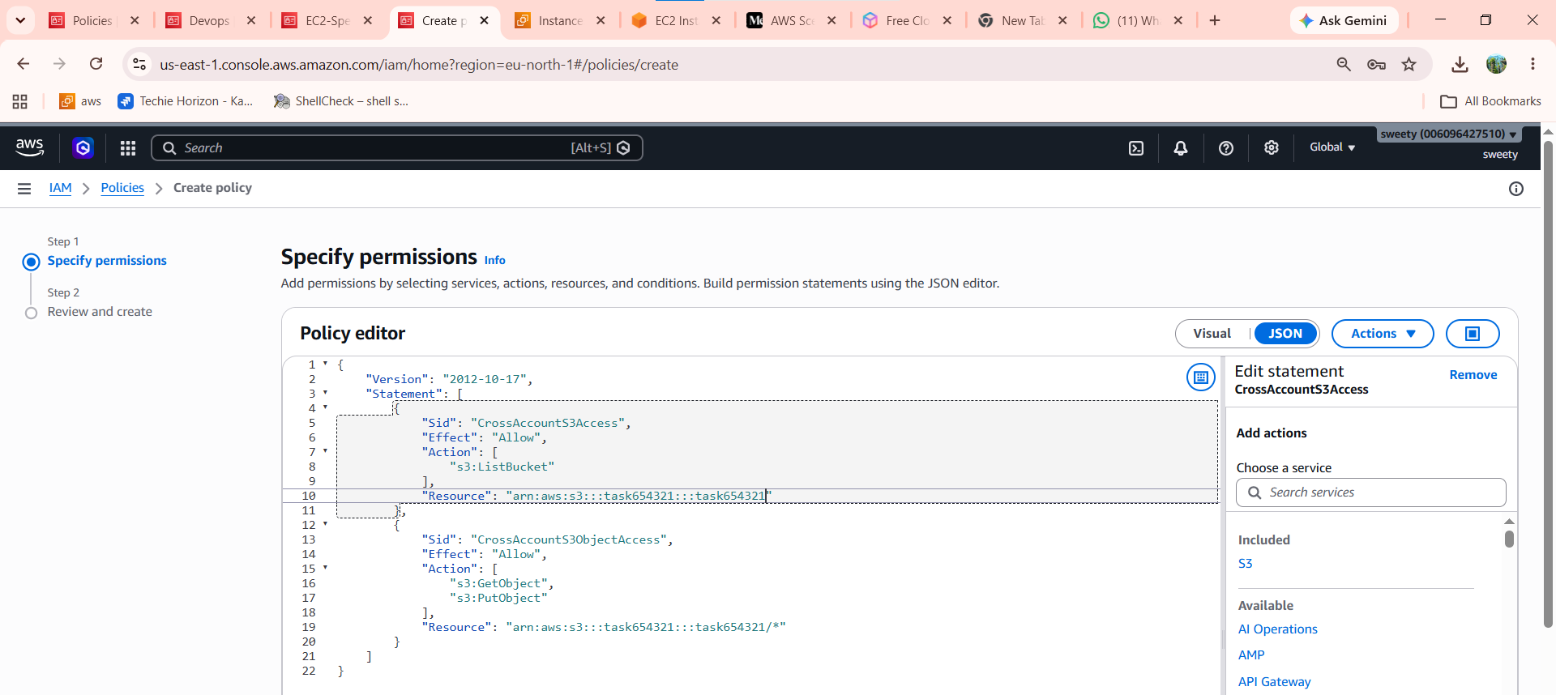
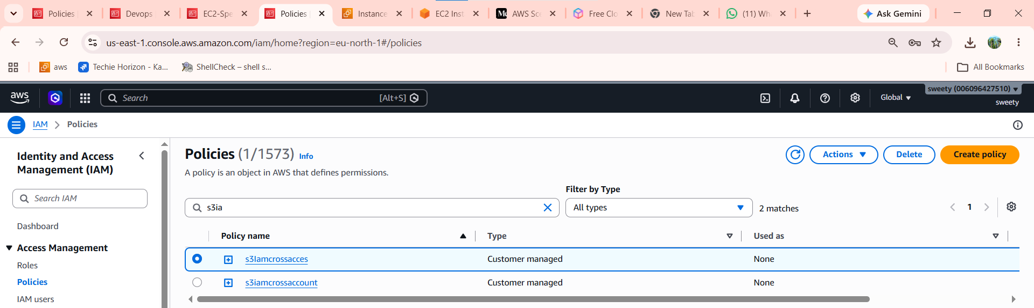
Testing
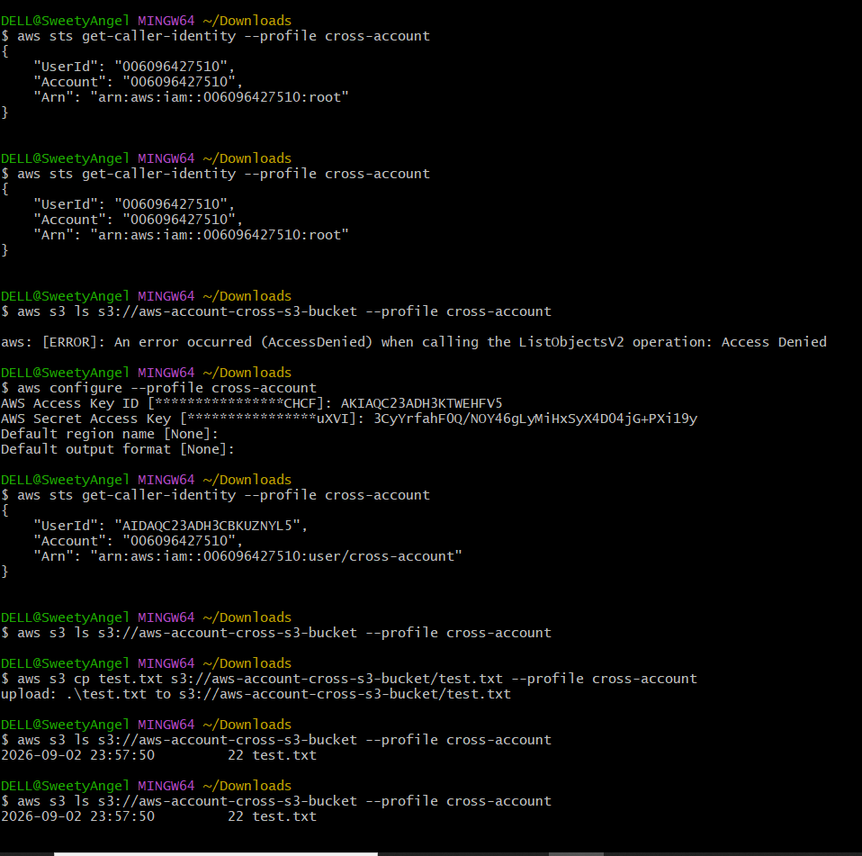
Screenshot: Successful file upload/download.
